PCR
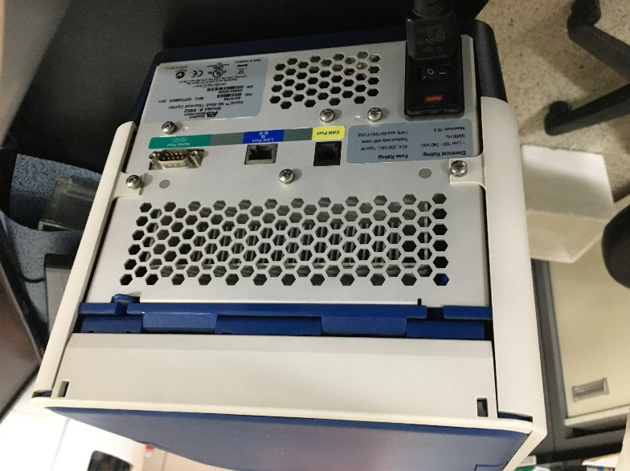
- Turn on the machine and wait to initialize.
- In the home screen, select “Browse/New Methods”.
- To create a new method, select “New”.
- Direct choose the factors on the screen for edition.
Temperature
change
time
cycles
temperature
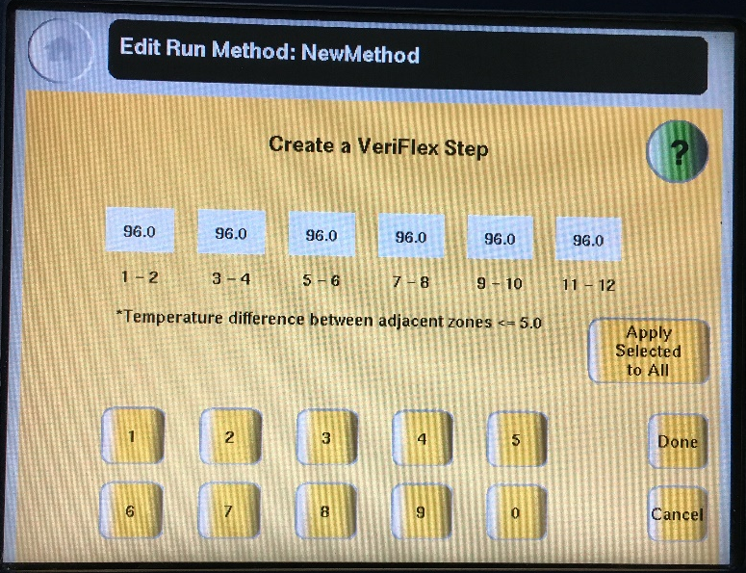
- Choose the whole step column, and set up temperature gradient. Save the file.

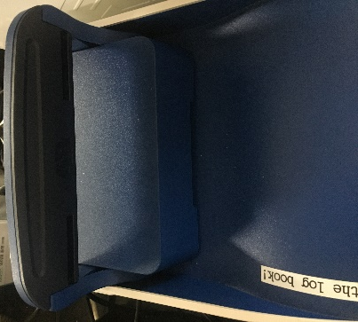
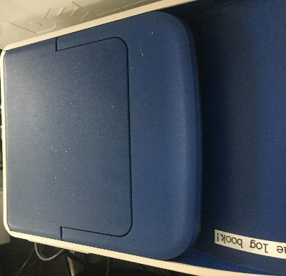
- 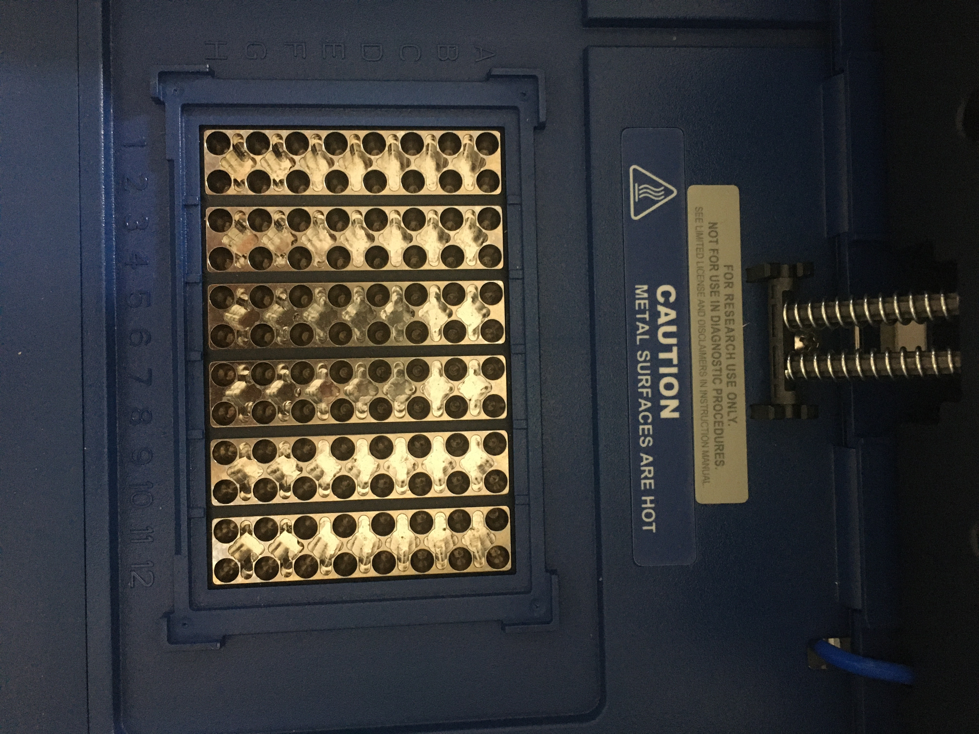Insert samples.
Gradient
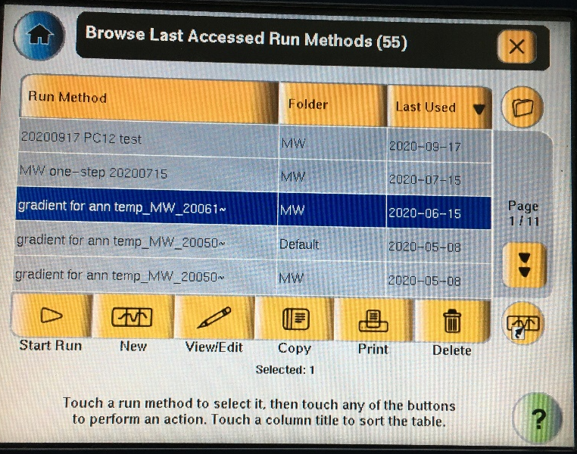
- 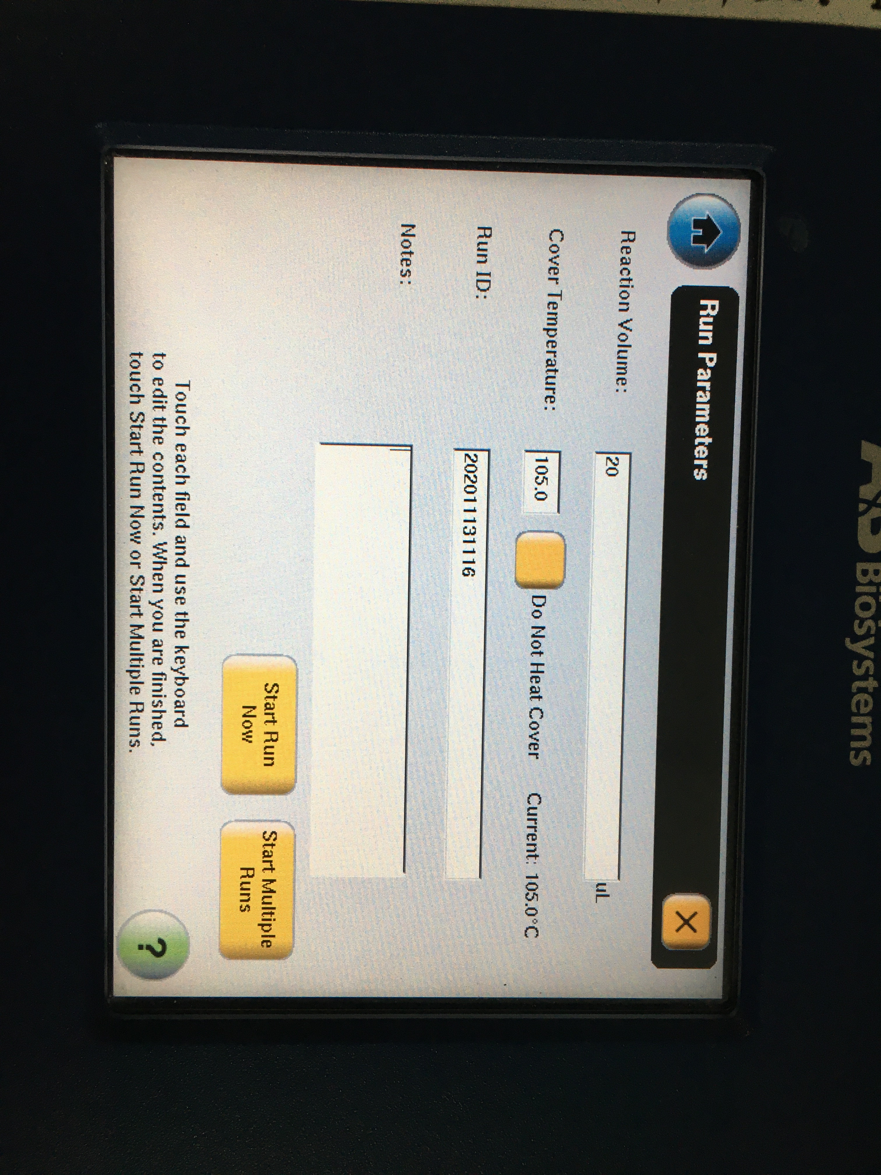Choose the saved file and start run.

Fluorescent microscopy
- 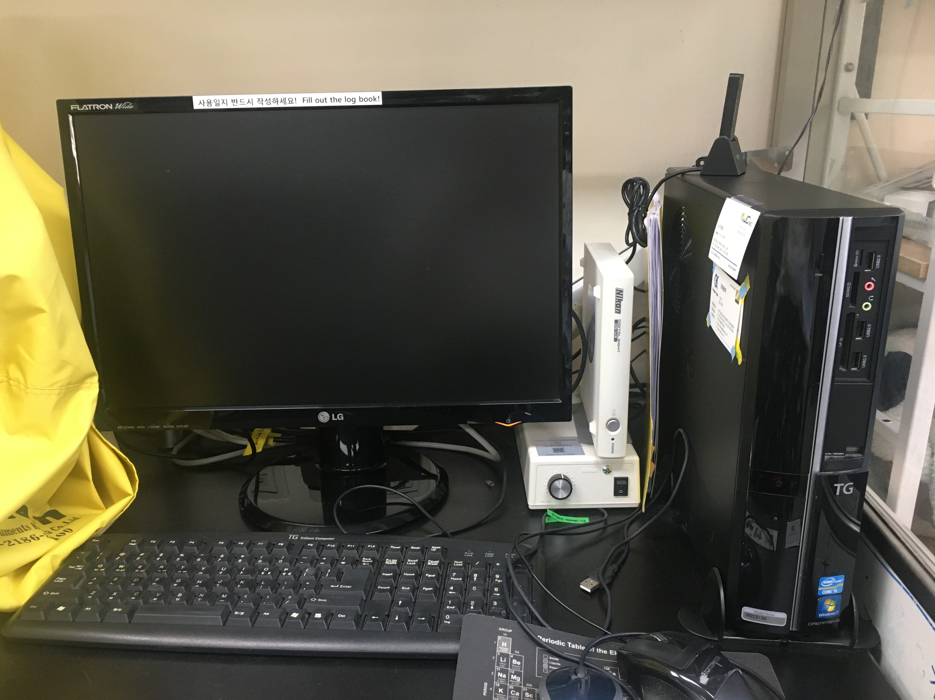Turn on the computer and the instrument.

- 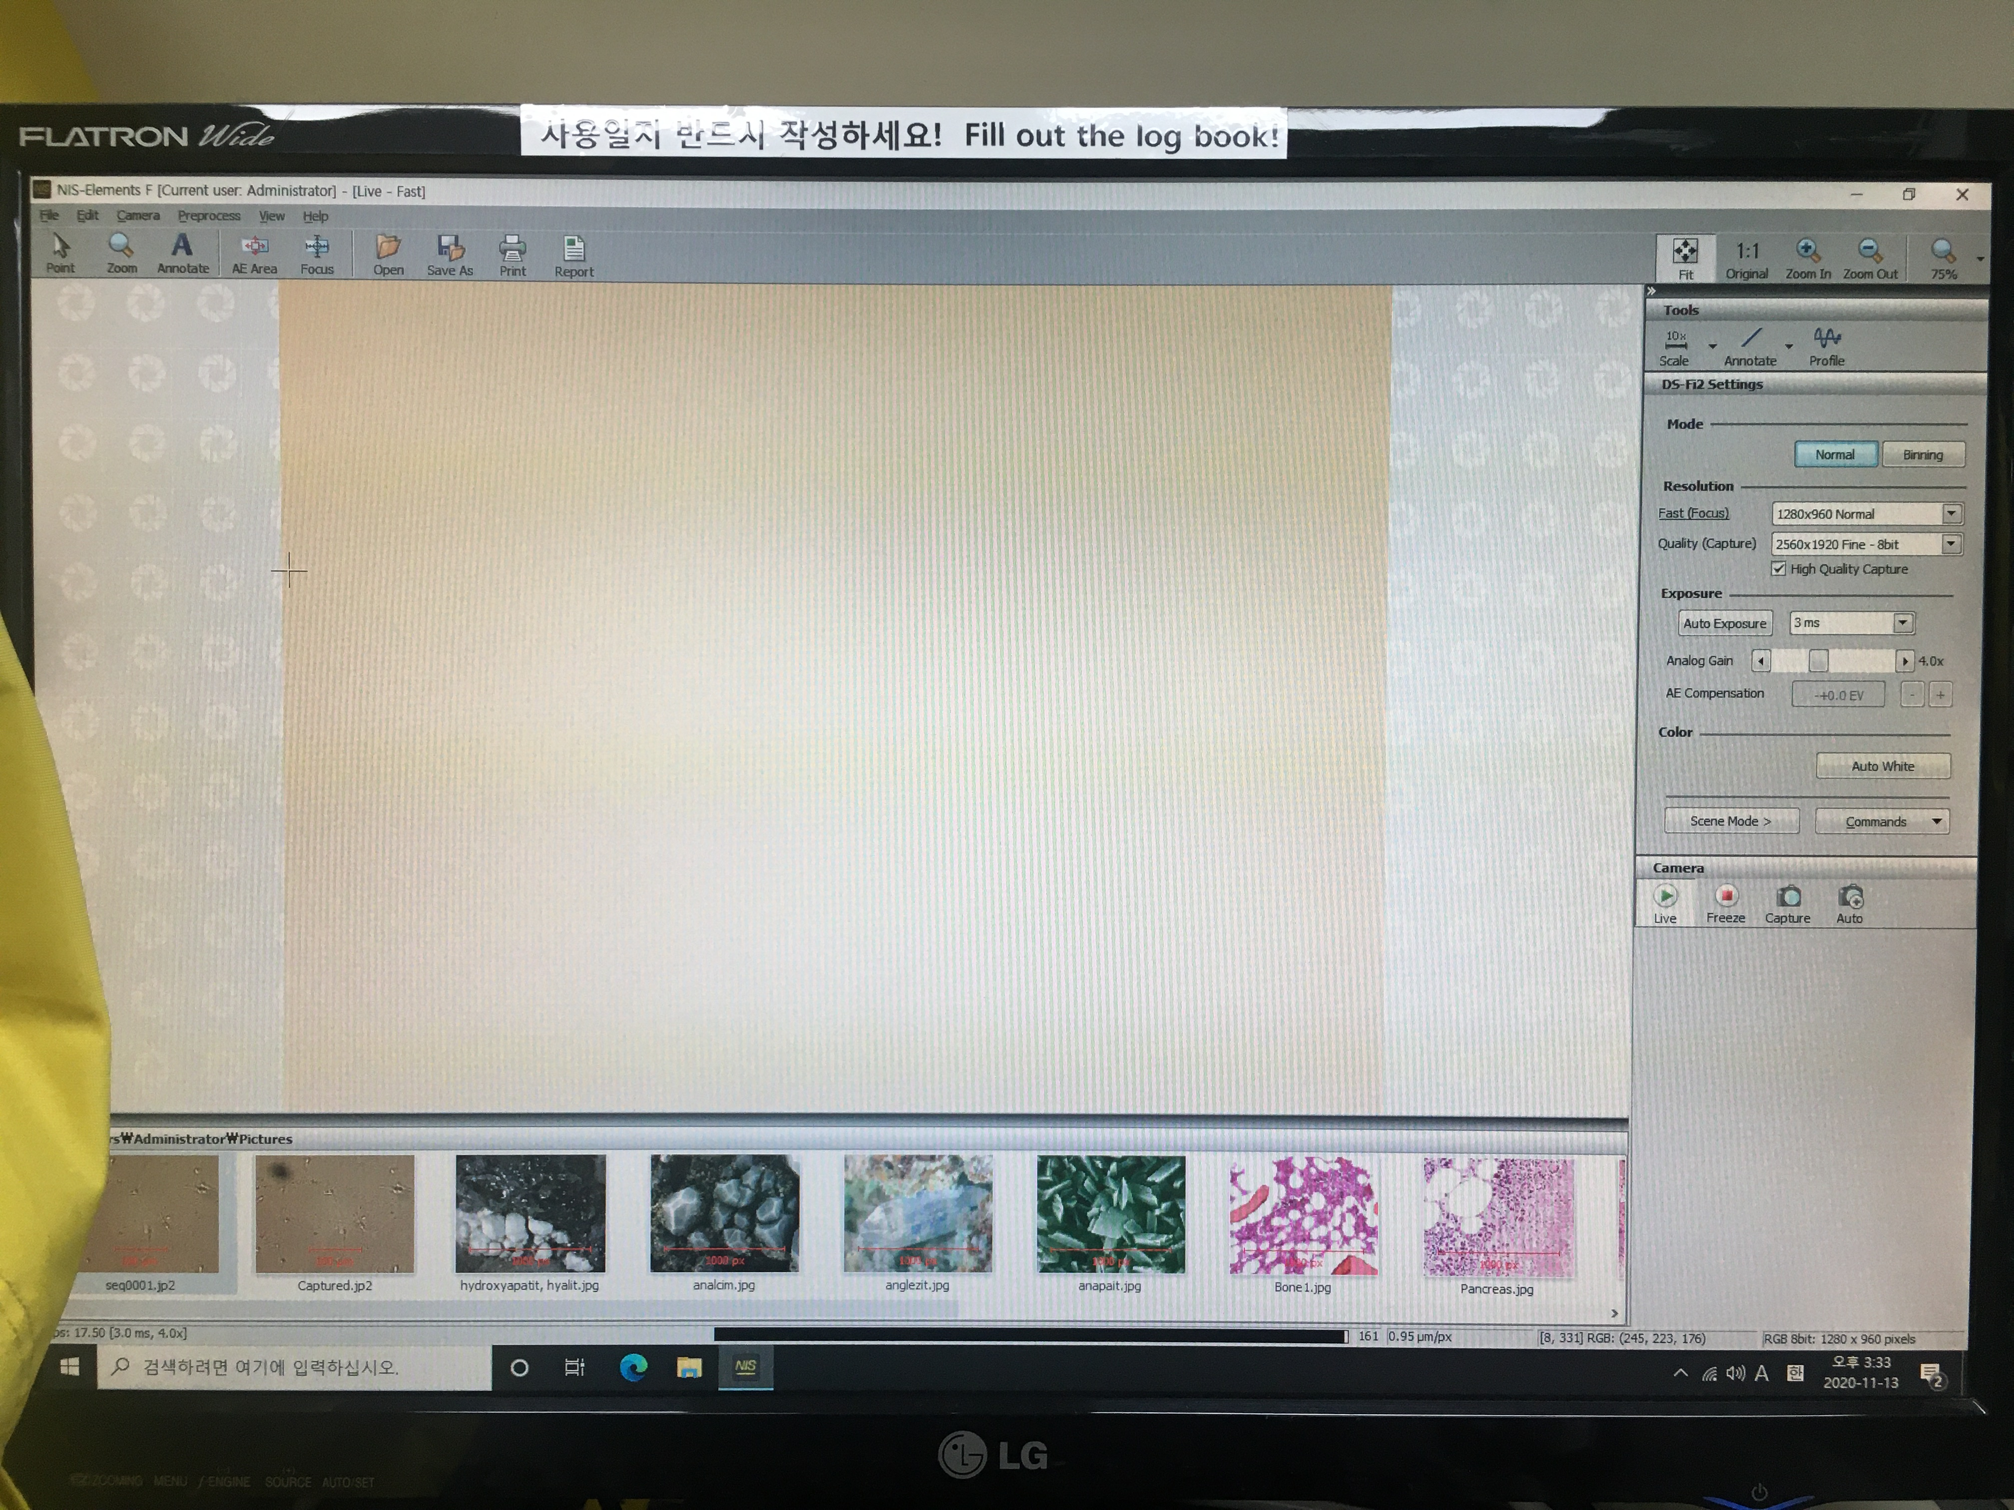Open the software
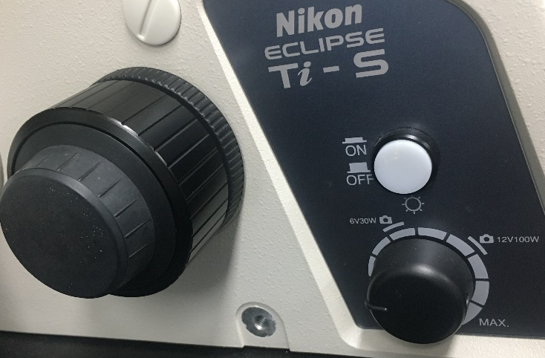
- For optical images, turn on the light, and rotate the port to “side”.
Side
Light
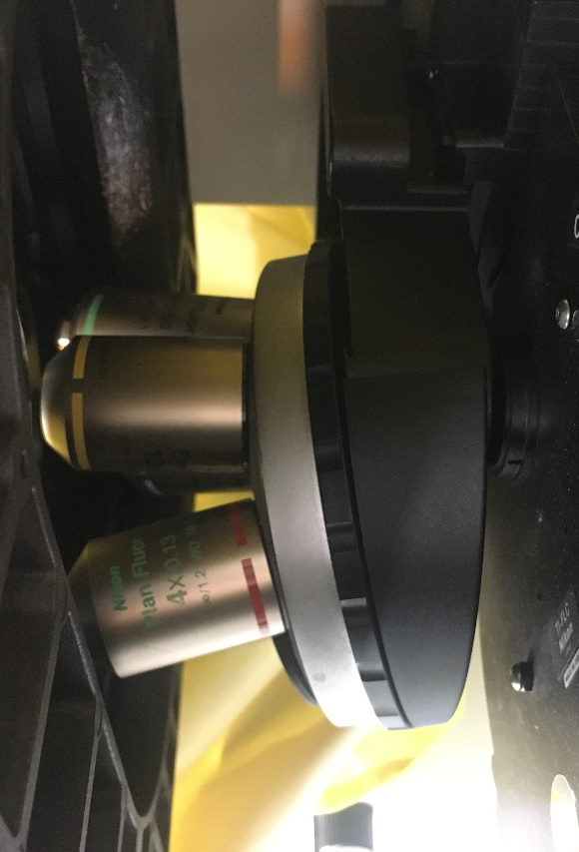
- Rotate to change the objective lens.
Lens
Rotate
- Adjust the exposure time and capture.

Focus
Focus

- For fluorescent microscopy, turn on the laser (the laser should be on for at least 30 min).
on
Main power
Laser power
on
off
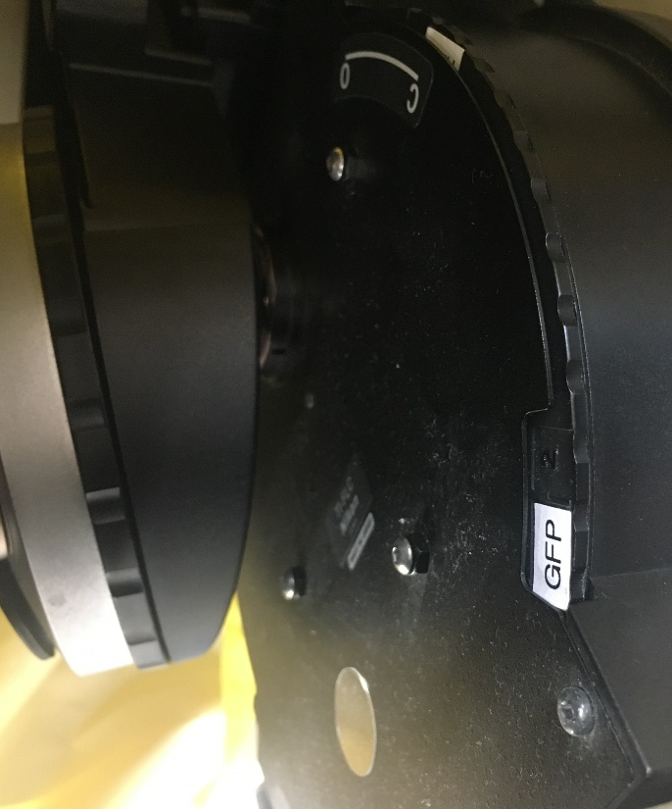
- Focus the sample under light microscope, turn off the light and change the filter. (blue-BPF, green-GFP, red-RFP)
Rotate
- Adjust the exposure time and capture.
Potentiostat
- Turn on the potentiostat.
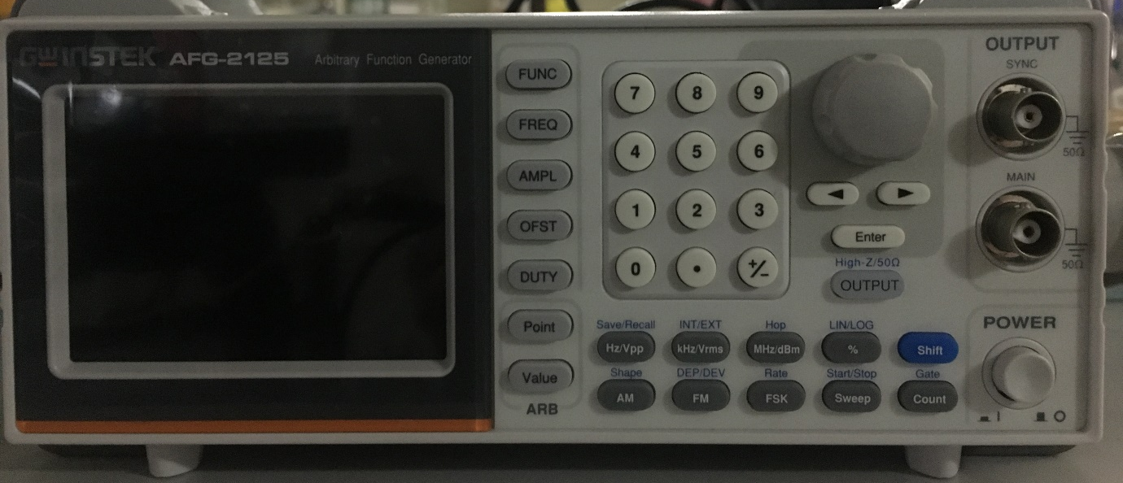
Main power
- Setting up parameters (function (pulse, sine …), frequency, amplification and offset). Push the corresponding button and input or rotate to adjust the value. Push “save” to save the parameters.
Save
Offset
Amplification
Frequency
Function
rotate
Input

- Connect to an output cable and push “output”.
Output
Connect to cable
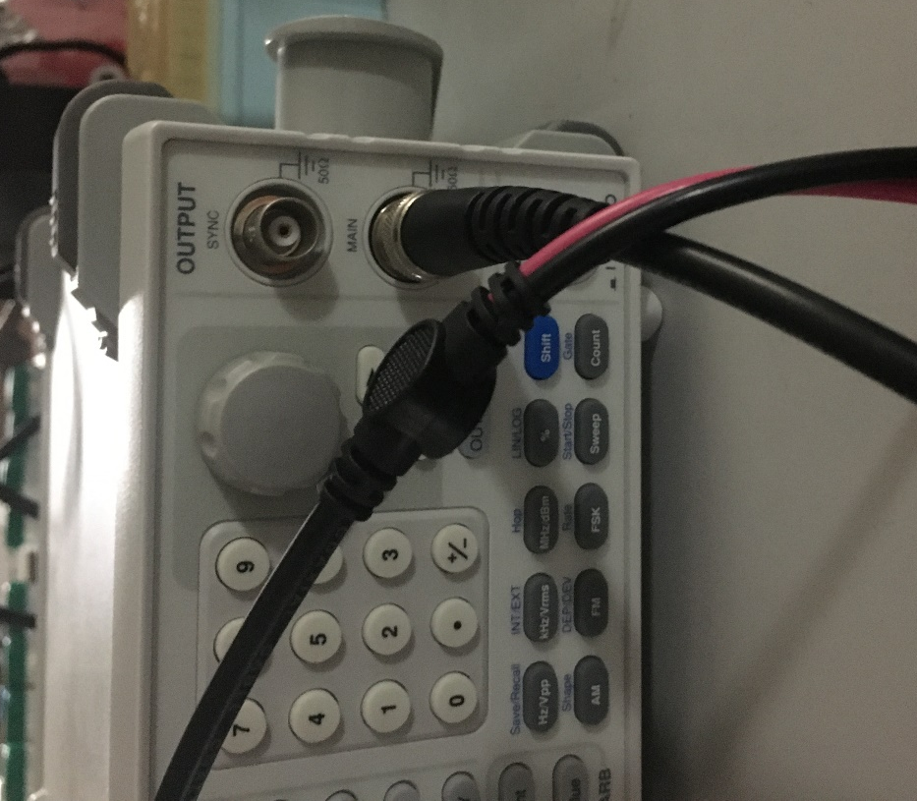
Cable

Fluorescence spectroscopy

- Turn on the device power and the fluorescent filter power switch in order.
- Open the computer program (RF-5301PC) and wait for the instrument to be set up.
- Set spectrum and quantitative mode in Acquire Mode.
- After determining fluorescence excitation and emission in Configure-parameter, adjust slit width and sensitivity.
- After adding 500µl of solvent to the cuvette, insert it into the instrument, click read, and press auto zero.
- Remove the solvent with a pipette, wash with water, and dry with a tissue.
- After adding 500µl of sample, put it in the device and press read.
- Remove the sample with a pipette, wash in the order of solvent and distilled water, and then remove moisture with a tissue.
- After measuring, manipulate-data print, copy it to a notepad, and take the result.
- Turn off the computer program, turn off the fluorescent filter, and turn off the power after 30 minutes when the wind gets cold.
Clean bench

- Turn the flow high, UV off, and light on, then open the clean bench window.
- When putting objects into the clean bench from the outside, be sure to sterilize them with 70% ethanol and wipe by a kimtech tissue.
- After completing the experiment, sterilize the equipment used inside the clean bench with 70% ethanol and wipe by a kimtech tissue.
- After closing the clean bench door, change the flow to low, UV on, and light off.
Organize your surroundings and keep them in their original state.

Plate reader

- Turn on the device by pressing the on button.
- Set the desired wavelength, press the out button and insert the 96-well plate.
- Press the In button to insert the plate, and press the start button to start.
- After the experiment type, remove the plate and press the off button long to finish.
DLS/zeta potential

DLS
- Turn on the power at the back of the device and start the zetasizer software.
- Open the cover, insert the cell, and close the cover.
-Add at least 1ml of sample.
- Check Measure-Manual, measurement type-size in the computer program, write the sample name, and select cuvette.
- After completion, a new window appears, press start.

Zeta potential
- Turn on the power at the back of the device and start the zetasizer software.
- Open the cover, insert the cell, and close the cover.
-Put the sample in a 500µl so that no air bubbles are generated.
- Check Measure-Manual, measurement type-zeta potential in the computer program, write the sample name, and select cuvette.
- After completion, a new window appears, press start.

Nanovue

- Turn on the power after removing the device cover.
- Set up the program to be used in the experiment.
- Open the sampling head, drop a 5µl blank and carefully lower the head to measure.
- Open again, remove blank with a tissue, and wipe with 70% ethanol.
- Drop a 5µl sample, lower the head again, measure, and wipe with ethanol.
- After the experiment type, press the home button of the device to return it to the initial state, turn off the power and close the cover.

pH meter

1. Press power (stdby) on the pH meter.
2. Remove the black cap of Electrode and rinse thoroughly with clean DW.
3. Immerse the electrode in the solution to measure the pH.
4. When the pH of the solution appears on the screen, adjust the desired pH with HCl and NaOH.
5. After adjusting the desired pH, measure until Stable appears on the screen.
6. After using the pH meter, rinse the electrode thoroughly with clean DW, empty the black cap, fill with new potassium solution, and insert the electrode.
7. Turn off the power by long pressing the stdby of the pH meter.

Caution !
- Handle with care to avoid breaking the electrode.
- To prevent the electrode from drying out, it must be completely immersed in a potassium solution.

Power supply

1. Turn on the power by pressing the button on the right.
2. To check the set voltage, press and hold HV OFF to check the voltage.
3. While holding down the HV OFF button, set the desired voltage.
4. Adjust the voltage setting by turning the roller after releasing the locking device next to the voltage.
5. After adjusting the voltage, press and hold HV OFF to check if the desired voltage is set.
6. After connecting the electrospinning nozzle and power supply voltage, press the HV ON button to make the voltage flow.

Caution!
- Be careful of electric shock because high voltage flows.
- Avoid contact with liquids.
- Do not change voltage during operation.

Syringe pump
- Fix the syringe to be used on the pump.
- Set the diameter of the syringe in the syringe pump setting.
- Set the desired flow rate.
- Press Start to operate the pump.

Caution!
- When using for electrospinning, the syringe pump must also be grounded.
- Set the diameter suitable for the syringe used.
- Syringe pump decimal point can be changed by pressing two buttons at the same time at the desired location.

FUME HOOD
CAUTION:
- Keep the hood sash closed as much as possible.
- Keep the hood slots and baffles free of obstruction by apparatus or containers.
- DO NOT permanently store apparatus or chemicals in the hood.
- DO NOT put your head in the hood when contaminants are being generated
- Solvent bottles in the fume hood must be capped when not in use.
- DO NOT make fast movements when taking items in and out of the hood.
- DO NOT place electrical receptacles or other spark sources inside the hood when flammable liquids or gases are present. No permanent electrical receptacles are permitted in the hood.
- Use an appropriate barricade if there is a chance of explosion, implosion or eruption.

CENTRIFUGE
OPERATION:
- Turn the power on
- Load evenly weighted samples at evenly place to avoid rotor imbalance
- Close the rotor lid and securely tighten the lid knob (ANGLE ROTOR ONLY)
- Close the centrifuge door by pressing down firmly until the latch handle is fully retracted
- Enter the desired run parameters manually.
- Press the START/STOP button to start centrifugation
- Open the lid once the run has been completed and rotor stops fully
- Carefully remove samples. Clean the instrument and the rotor thoroughly.
CAUTION:
- Check tubes and rotors for any cracks and deformities before each use.
- Do not attempt to open the lid unless the rotor has stopped completely.
- Do not exceed safe rotor speed.
- The operator should not leave the centrifuge until full operating speed is attained and the machine appears to be running safely without vibration.
- Stop the centrifuge immediately and unplug the power cord if an unusual condition (noise or vibration) begins.
- If tube breakage occurs, turn centrifuge off immediately. Leave for 30 minutes to reduce the risk of aerosols. The operator should wear proper gloves, remove debris, clean and disinfect centrifuge interior and rotors.
- Clean all spills immediately and decontaminate the instrument and rotor after use with biological or radioactive materials.

VACUUM DRY OVEN
OPERATION:
- Turn the power of the chamber on and enter the desired run parameters manually IF NEEDED. (Ex: required temperature higher than RT)
- Put in the sample in the oven and close the door.
- Liquid nitrogen was fill in the cold trap container and cover the container with Al foil.
- Connect the vacuum pump hose with the cold trap.
- Vent valve handle on right side must be located to CLOSE.
- Turn Vacuum valve handle on the left side to 12 o’clock position (OPEN)
- Start Vacuum pump to create vacuum inside chamber.
- After completing vacuuming, turn Vacuum valve handle on left side to 3 o’clock (Close).
- Unplug the hose between the vacuum pump and the cold trap.
- Stop the Vacuum pump.
- After the samples are properly dried. Turn Vent valve on the right side to OPEN and wait until the air is fully released from chamber before collect the samples.

CAUTION:
- In vacuum condition, inner chamber temperature must be lower than the sample's Boiling Point. DO NOT use a sample that is easy to be sublimated
- BEFORE TURN THE VACUUM PUMP OFF, you have to make VACUUM VALVE handle set to CLOSE position and stop vacuum pump, unplug the hose between the vacuum pump and the cold trap. Otherwise, vacuum pump oil may flow backward into the chamber due to vacuum state of chamber.
- Exchange vacuum oil regularly at a 100hr interval of vacuum pump use.
The cold trap should be checked before use and washed with Ethanol 70% after use.
- Please do not insert any material that can apply electric current or can be inflammable. It can cause electric shock or a fire.
- When clean the unit, do not pour water to external body directly

DRY OVEN
CAUTION:
- DO NOT keep explosive powders or solvent/air mixtures in the vicinity
- DO NOT allow the device to get wet while operating or maintaining
- The temperature should be checked regularly.
- The door must be properly closed while the device is operating normally to ensure that there is stable temperature in the interior.

Ultrasonic cleaner
Operation
- Turn the power on
- Select the proper mode (heat, sonics, degas) for operation by ‘select option`
- Place and fix tubes or flasks in reservoir
- Start operation of selected mode by pressing ‘on/off’
- Turn off the operation by pressing ‘on/off`

Caution
- Change the water regularly and add 0.01% of sodium azide to prevent contamination
- Fill around 5cm of water inside of the reservoir for proper operation
- Solution level must be 3cm from the top
- Do not use flammable solution
- Use only water based solution

Water bath
Operation
- Turn the power on
- Set proper temperature for operator’s sample
- Wait until the water is heated up to set temperature
- Turn the power off after use

Caution
- Regularly check the reservoir and change the water by add 0.01% of sodium azide to prevent contamination
- Drain and clean the reservoir when contaminant is visualized
- Always allow the bath fluid to cool to ambient temperature before draining
- Never operate the Water Bath without bath fluid in the reservoir

Balance scale
Operation
- Turn on the scale
- Stabilize until display shows ‘0`
- Place proper apparatus on the weighing pan and close the side walls
- ‘Zero’ and weight sample
- Clean the inside of scale by dust blower
- Turn off the scale

Caution
- Do not over weight more than 220g
- Clean inside of scale after use
- Turn off the scale after use
- Check the balance bubble is at the center of circle

Liquid nitrogen
Caution
- Liquid nitrogen level must be over 20cm -

How to operate

Auto Mode
Before drying
1. Press power and check the condition of filter, drain cork and vacuum valve
2. Press ‘auto` and then press ‘start`
3. Wait until the process reach to vacuum state
4. When the vacuum drop down to 0 torr, connect the bottle and twist the valve to ‘open`

After drying
1. Take out the sample without turning off the machine
2. Press defrosting (when the temperature reach to 15℃ the machine automatically stop)
3. After defrosting drain the water by opening the drain cork

Caution
● After turning off, reactivate the machine 24h later for stabilization of pressure
● Do not turn off the machine until the thick ice is frozen on the coil
● Clean the filter before every use
● Keep the inside of the chamber dry

CO2 incubator
- MODEL : 3111
- Repairer number : 1661-9555 (thermo fisher)

OPERATION
1. Sterilization must be maintained
2. Check Temp : 37℃, CO2 : 5% on top screen before inserting
plate
3. Change the water inside the incubator every week
→0.01% sodiumazide in DW

Caution
● Be careful not to mold
→ If there is mold, turn off the power and clean the inside with IPA
● Whenever the poser is off, must be call the engineer for CO2 calibration
● Check the amount of CO2 remaining in the CO2 tank next to the clean bench
frequently

Deep freezer
- MODEL : CLN-30U
- Repairing number : 033-743-6806 (재마무역)

OPERATION
1. Make sure the temperature is near -80℃
2. Open the large outside door and open the desired compartment
3. After inserting the sample, close the door and hang the two locks
4. Close the big door

CAUTION
● Once the door is closed, the door will not open immediately due to the pressure
difference
→ Open the black valve on the left to adjust the internal and external
pressure and open the door
● A lot of frost on the inside
→ Must be scraped off frequently with a scraper

Shaking incubator
- MODEL : MCO-20AIC
- Repairing number : 02-891-02053 (재마무역)

OPERATION
1. Check whether the power is on and at 37 ℃
2. When buzzer is heard, open and close the inner door several times, the close
the door again. Or (Buzzer) button to turn off sound

CAUTION
● Do not prevent samples that are not used inside the incubator

